README

Thursday, October 26, 2017

This document presents a brief background on the mechanics of an MTConnect agent implementation for Universal Robots. This document concerns itself with how the embedded UR "Adapter" in the Agent operates in order to communicate with a UR robot. Basically, a UR adapter reads a configuration file, then reads real-time data from a UR robot using the established UR TCP protocol and translates this information into MTConnect state and data information. Multiple adapters to UR robots are possible, each contained within one MTConnect Agent. This document also describes in detail the data gathering for a Universal Robot (UR) using a socket interface.

The document includes a brief background on MTConnect, UR robot background, system architecture, communication scheme, and installation notes. This document assumes the reader is familiar with MTConnect operation, and for deeper explanation of MTConnect, please refer to MTConnect URL: <http://www.mtconnect.org/> for more information.

# Background

## MTConnect Overview

MTConnect is an evolving standard developed to facilitate the exchange of data on the manufacturing floor. The MTConnect open specification provides for cost effective data acquisition on the manufacturing floor for machine tools and related devices. MTConnect is based upon prevalent Web technology including XML and HTTP. Figure 1 shows the MT Connect architecture. An “MTConnect Device” is a piece of equipment – in this case a UR robot, which (optionally) includes an MTConnect Adapter so that we can get data from it. The “Agent” is a process that acts as a “bridge” between a device and a factory “Client Application”. To learn more about MTConnect visit: <http://www.mtconnect.org/>

Figure 1 shows a typical MTConnect UR Robot system architecture (with one or more UR robot devices). Communication between a Windows PCs and the UR robot is assumed, communicating over Ethernet to communicate the UR robot status.



Figure MTConnect NIKON CMM Logging Agent system architecture

This document describes the communication and data gathering software technology used to communicate with a UR robot to provide data for an MTConnect Agent to make available to clients. Multiple adapters to UR robots software are possible, each contained within one MTConnect Agent.

Universal Robots is a Danish manufacturer of smaller flexible industrial robot arms whose primary application are as collaborative robots. Collaborative robots differ from traditional robots by being able to work side-by-side with human workers as the robots are deemed inherently safe, and thus do not require a fence to safeguard workers from dangerous robot behavior. A collaborative robot differs from a traditional industrial robot due to the fact that a collaborative robot is designed to work alongside human employees, while an industrial robot replaces a worker (as it unsafe for an industrial robot to even be near a human). In theory, a collaborative robot can assist employees with work that may be too dangerous, strenuous, or tedious for them to accomplish on their own, creating a safer, more efficient workplace. By contrast, industrial robots are used to automate the manufacturing process almost entirely without human help on the manufacturing floor.

UR robots also claim to be more easy to teach program than industrial robots because they can be programmed by moving the arm to the desired teach position. Industrial robots cannot be so easily reprogrammed since they are dangerous and they require a joystick to move the robot to the desired position. In either case, it would be preferable if the robot could use sensing and background engineering to determine the desired goal position. Many robots use CAD models of the factory to understand the manufacturing environment and goal positions, but this is a non-trivial integration exercise, especially in a one-off production environment.

Figure 1 show the three different sizes of Universal Robots – UR3, UR5 and UR10, which are named for their payload weight in kilograms and vary in size, reach, weight and footprint. The UR robot's somewhat dated basic specification [1]:

* Max load capacity of 11 lbs for the UR5 (UR5 AE3) and 22 lbs for the UR10
* Max speed of 1 meter per sec under full load
* Simple teaching style programming with the ability to create complex logic in a point and click environment
* Full scripting language for complex programming required
* I/O handshaking and fieldbus communications
* Torsion sensing technology for use in collaborative situations
* Compatible with industrial vision systems such as Cognex
* Repeatability of +/- 0.004"
* Environmental Rating of IP54
* Weight without Pedestal: 40.6 lbs for the UR5 (UR5 AE3) and 63.7 for the UR10
* Calculated Life of 36000 Hours of Operation at rated loads



Figure Universal Robots - UR3, UR5, and UR10

Of interest in this document is reporting status of UR robots. At a low level of control, UR robots have a controller called "URControl", which is the low-level robot controller running on the Mini-ITX PC in the controller cabinet. When the PC boots up URControl starts up as a daemon (like a service) and PolyScope User Interface connects as a client using a local TCP/IP connection and listens for socket connections. Monitoring status of a UR robot is done by writing a client application, in this case the MTConnect Agent, and connecting to URControl using a TCP/IP socket, with these parameters:

* Hostname IP
* port: 30002

The UR MTConnect Agent contains a back end adapter that communicates with the UR controller via the TCP/IP socket. In general, UR supplies three TCP/IP interfaces: primary, secondary and real-time. The secondary communication channel was used to retrieve robot status at 15Hz. With the MTConnect agent running, a connection to each UR robot is established to receive status communication from the robot. Then, if you bring up a browser and enter the IP plus port 5000 and the command current, e.g., <http://xxx.xxx.xxx.xxx:5000/current> the agent will return the current state of the data items in the UR robot. Shown below is a formatted output table from a VB script that extracts the MTConnect agent XML from one UR robot .

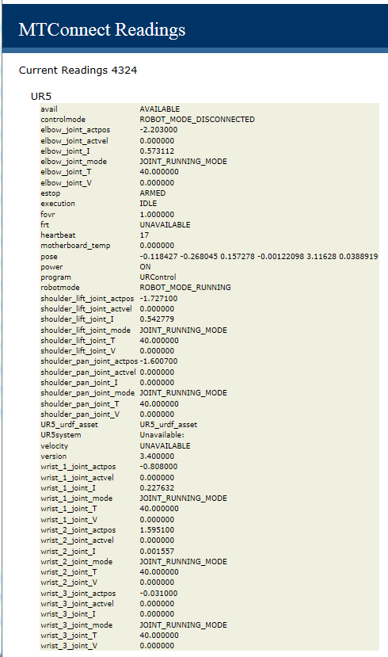

Figure Web-browser Display Showing Table of MTConnect Agent Data Items

The UR TCP/IP communication streams the status of the robot over the socket connection. The MTConnect Agent back-end adapter reads the status, and decodes these UR robot message into a series of C++ structures. These UR status interfaces include:

struct ur_additional_info;

struct ur_cartesian_info;

struct ur_configuration_data;

struct ur_force_mode_data;

struct ur_joint_data ;

struct ur_joint_limits;

struct ur_joint_maxs;

struct ur_key_message;

struct ur_label_message;

struct ur_masterboard_data;

struct ur_message_header;

struct ur_popup_message;

struct ur_request_value_message;

struct ur_robot_comm_message;

struct ur_robot_message;

struct ur_robot_mode_data ;

struct ur_runtime_exception_message;

struct ur_security_message;

struct ur_text_message;

struct ur_tool_data;

struct ur_var_message;

struct ur_version_message;

Importantly the interface robot_mode_data, joint_data, cartesian_data, version_message, masterboard_data, and configuration_data are the status data buffers that are used by the MTConnect back-end Adapter. Within these data buffers the UR robot status is collected and then interpreted into MTConnect standard data items. Although many MTConnect items are CNC –centric and aren't intuitively reflected within the UR robot status buffers (e.g., MANUAL versus AUTOMATIC mode), it is possible to convert the UR robot status into an MTConnect device status representation. In fact, the UR robot has more than sufficient status information, so that determining the data items for the MTConnect Agent to monitor when displaying a UR robot state can depend on the particular client application. For example, an OEE client application would require different data items than a client application to determine the prognostic and health of the robot.

|  |  |
| --- | --- |
| MTConnect Data Item | UR robot interface item |
| power | ON if ur_robot_mode_data.isPowerOnRobot |
| mode | Became robotmode and controlmode tags  ur_robot_mode_data.robotMode  ur_robot_mode_data.controlMode |
| execution | ACTIVE:ur_robot_mode_data.isProgramRunning INTERRUPTED:ur_robot_mode_data.isProgramPaused  READY: state not above |
| axes status | ur_joint_data gives position, velocity and other low-level joint parameters as well as joint_mode |
| estop | TRIGGERED: if ur_robot_mode_data.isEmergencyStopped  ARMED: otherwise |
| fovr | ur_robot_mode_data.targetSpeedFraction |
| pose or PATH_POSITION | Combination of r_cartesian_info x,y,z,rx,ry,rz values. |
| message | Unclear, many text messages returnd by UR |

The match between a CNC-centric MTConnect and a robot domain is not perfect. The description of axes (joints in robot terminology) is one apparent difference. The natural match, a "rotary" axis in MTConnect (such as a CNC spindle), is considered a continuous axis in typical robot terminology. However, the concept of a rotary MTConnect axis was used, but was treated as a robot rotary joint (with units in radians not RPM and not continuous). This was among some of the differences in coalescing the two-application domain's terminology, but did not cause any major programming issues, but may cause a misunderstanding of output.

# UR Robot URDF Information from MTConnect Agent

Enterprise integration of UR factory robots using MTConnect would be beneficial for OEE, simulation, downtime and repair response, prognostics and health management, among other client applications. One aspect of robot's utility that is useful is a complete model of the robot. For example, the popular Robot Operating System (ROS) uses the Unified Robot Description Format (URDF) as a general-purpose robot model, which includes a wide range of robot specification information.

ROS uses the Unified Robot Description Format (URDF) as a general-purpose robot specification model. URDF covers the kinematic and dynamic description of the robot, the visual representation of the robot, and the collision model of the robot. Of note, since URDF is an XML specification, URDF is limited to robots that exhibit only tree structures representations, ruling out all parallel robots like Stewart Platforms. However, most Industrial Robots are kinematic chain robots and so can be modeled as a serial set of links and joints. Multi-arm robots can also be modeled in URDF as a kinematic tree of links connected to multiple joints, such as a headed robot with two arms.

URDF is an XML specification to describe a robot. Because it is an XML specification, the information is modeled as a tree with elements (e.g., "<Name>'') with subelement branches under elements. Each robot is modeled in ROS by an URDF file, which contains

**Link Information** Link elements describe a rigid body with an geometry, inertia, visual features, obstacle bounds and other robot properties. The visual element within the link element contains the specification for display of the link in visualization tool (either a mesh or a geometry element). The visual also contains the material element which sets the color of the link.

**Joint Information** Joint elements describe the kinematics and dynamics of the joint and also specify the safety limits of the joint. Joint elements contain elements for parent link, child link, axis of rotation, calibration, dynamics, limit, and safety controller information. Joints are also able to mimic other joints. URDF assumes each joint is either a revolute, prismatic, fixed, or continuous type joint which depending on the type can have position, velocity and effort limits specified.

Fortunately, MTConnect has the capability to seamlessly pass this URDF information to clients. Besides the device data items, MTConnect standard addresses other auxiliary manufacturing equipment that are not a component of a machine[2]. To allow generating and managing such auxiliary data models at runtime, MTConnect assets were introduced. Examples of MTConnect assets are objects like cutting tools, workholding systems, parts and fixtures. MTConnect assets offer a good framework for future expansions so that the URDF robot specification information can be channeled through MTConnect agent as an asset.

Since MTConnect can incorporate and transport standardized XML data developed independently from the core MTConnect information models, passing URDF XML as an asset is straightforward. MTConnect defines "assets as an associative array of key/value stores in which to store the XML. This allows the ability to collect and report entire XML documents as they change within applications. Below, the XML shows how an AssetChanged tag with an asset type URDF and MODEL value that would be updated within the MTConnect XML query to indicate new quality results from an inspection.

<AssetChanged dataItemId="dev_asset_chg"

timestamp="2017-09-08T19:42:16.855924Z" sequence="46"

assetType="URDF">MODEL</AssetChanged>

For our implementation, the ROS URDF XML was used that is then accessible via the Internet with the following query to an MTConnect agent:

http://xxx.xxx.xxx.xxx/asset/MODEL?type=URDF

where xxx.xxx.xxx.xxx is the IP address of the MTConnect server and which returns an URDF XML "web page". So, the URDF is conveyed to MTConnect clients as "Assets". If you on the host machine of the UR MTConnect agent and type in the URL <http://127.0.0.1:5000/assets>, you will get a XML description with the URDF XML embedded inside the MTConnect XML. Below is a screen snapshot of the assets query of the MTConnect agent for the asset named UR5.

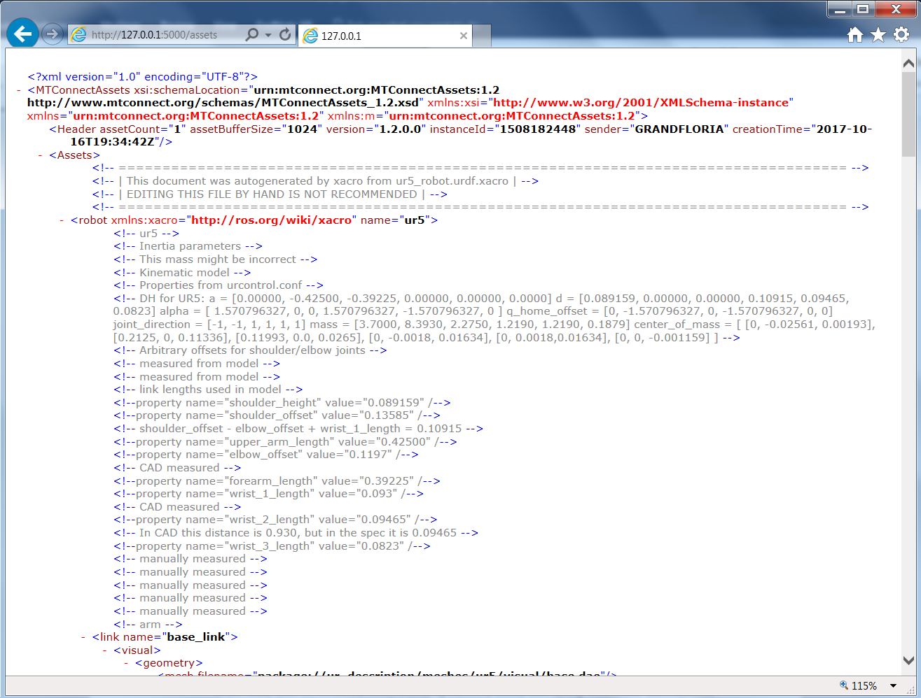

Figure URDF for UR5 Robot as MTConnect Asset

Within the UR Agent, in order to convey the asset, you need to have an asset declared in the MTConnect devices data item specification. Thus, the MTConnect probe must contain a data item to reflect the existence of the URDF asset.

<DataItem id="UR5_urdf_asset" type="ASSET_CHANGED" category="EVENT"/>

For the UR MTconnect agent to be reported via a query, C++ code transferred a URDF file that was read into a string and then passed into the core MTConnect agent using the addAsset function call. To alleviate XML confusion, the URDF header <?xml version="1.0" ?> was removed, or a web browser would hang at the returned XML. To use addAsset, the device, the id of the asset data item (UR5_urdf_asset), the textual body of the asset and the type (Robot) of the asset must be provided, as shown below:

void AdapterT::addUrdfAsset (std::string urdfstr)

{

std::string aId = this->mDevice + "_urdf_asset";

// remove the <?xml version="1.0" ?> as it messes up web browsers

size_t n = urdfstr.find("?>");

if ( n != std::string::npos )

{

urdfstr = urdfstr.substr(n + 2);

}

// <DataItem id="m1_urdf_asset" type="ASSET_CHANGED" category="EVENT"/>

std::string aBody = urdfstr;

std::string type = "Robot";

::Device *device = mAgentconfig->getAgent( )->getDeviceByName(mDevice);

mAgentconfig->getAgent( )->addAsset(device, aId, aBody, type);

}

Once the asset has been registered with the agent, the MTConnect agent status for the UR5_urdf_asset data item reflects that data is available.

# Version Information from MTConnect Agent

The version information of the various MTConnect components is available through web browser access. It is uses simple XSLT formatting of the XML. The open source core MTConnect agent is downloaded from github and “frozen”. The 1.2 version is used but is rebuilt when the entire agent is compiled.

MTConnect Core Agent Version 1.2.0.0 - built on Wed Oct 18 17:37:49 2017

It is not perfect but the output shown below gives an indication of the software involved in the MTConnect Agent operation. It can be modified to include other version information, but requires a recompilation at this time.

Thus, to get the version information in a web page, one can log onto the host PC of the MTConnect Agent, start a web browser, and type in this URL:

<http://127.0.0.1:5000/version>

If the UR MTConnect Agent is running you should receive a formatted Web Page as follows:

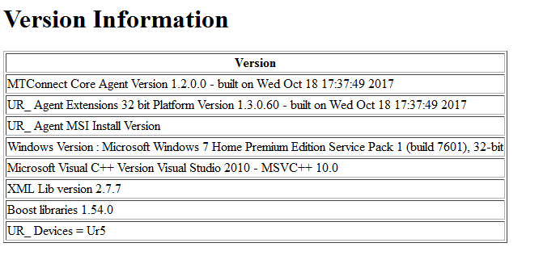

Figure UR MTConnect Agent Version Table

# UR Simulator

UR supplies simulators for all UR robots that run on a Linux box. The simulator is packages as ‘ursim-3.4.4-97.tar.gz ont the Universal Robotics’ web site. The web site <https://www.universal-robots.com/download/?option=26264> contains the different simulator versions matching different UR interfaces and further details on installing and running the simulator are given. Briefly, the UR web site explains how to install the Universal Robots software (GUI and controller) on Ubuntu Linux version 10.04. You should pick the interface version that matches your You will need sudo privileges to install the simulation package.

1. Download
2. Change into the downloaded folder, and unpackage the archive, for example, package ursim-3.4.5-100.tar :

cd /usr/local/ursim/

1. Install the UR robot simulator:

cd /usr/local/ursim/ursim-3.4.5-100

./install.sh

1. Run the simulator:

./start-ursim.sh UR5

You should see a popup Screen:

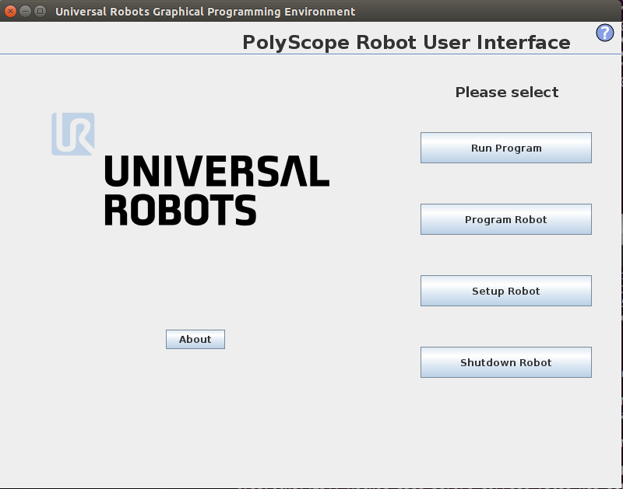You can verify that the UR simulator is working by using telnet to the local machine to port 30002 and seeing a binary stream of data using telnet. For example, bring up a Linux terminal, and type in:

> telnet 127.0.0.1 30002

Note, you should check if there is a firewall blocking access to port 30001, 30002 and 30003. This was not a problem on our Ubuntu Linux installations.

Interestingly, the UR web site has simulations for all the interface versions available corresponding to their actual robots. The code for the UR_Agent is supposed to recognize the version differences and resolve the conversion from binary socket communication into C++ UR structures.

# UR Version of Interfaces Table Comparison

The UR communication interface has several incarnations for different versions. This can be confusing. There is a breakdown of each interface in Excel Spreadsheet format supplied by Universal Robots. Instad of scanning across worksheets, the following table attempts to collate each INPUT interface into a table with changes noted between versions.

Foremost is the robot mode interface which supplies the current operating state of the robot:

|  |  |  |  |  |  |  |  |  |
| --- | --- | --- | --- | --- | --- | --- | --- | --- |
| Interface | 1.6 | 1.7 | 1.8 | 3.0 | 3.1 | 3.2 | 3.3 | 3.4 |
| Robot  Mode  Data | int packageSize  unsigned char packageType  uint64_t timestamp  bool isRobotConnected  bool isRealRobotEnabled  bool isPowerOnRobot  bool isEmergencyStopped  bool isSecurityStopped  bool isProgramRunning  bool isProgramPaused  unsigned char robotMode  double speedFraction | ibid | ibid | int packageSize  unsigned char packageType  uint64_t timestamp  bool isRobotConnected  bool isRealRobotEnabled  bool isPowerOnRobot  bool isEmergencyStopped  bool isProtectiveStopped  bool isProgramRunning  bool isProgramPaused  unsigned char robotMode  **unsigned char controlMode**  **double targetSpeedFraction**  **double speedScaling** | ibid | int packageSize  unsigned char packageType  uint64_t timestamp  bool isRobotConnected  bool isRealRobotEnabled  bool isPowerOnRobot  bool isEmergencyStopped  bool isProtectiveStopped  bool isProgramRunning  bool isProgramPaused  unsigned char robotMode  unsigned char controlMode  double targetSpeedFraction  double speedScaling  **double targetSpeedFractionLimit** | ibid | ibid |

|  |  |  |  |  |  |  |  |  |
| --- | --- | --- | --- | --- | --- | --- | --- | --- |
| Interface | 1.6 | 1.7 | 1.8 | 3.0 | 3.1 | 3.2 | 3.3 | 3.4 |
| Joint  data | double q_actual  double q_target  double qd_actual  float I_actual  float V_actual  float T_motor  float T_micro  unsigned char jointMode | ibid | ibid | ibid | ibid | ibid | ibid | ibid |

|  |  |  |  |  |  |  |  |  |
| --- | --- | --- | --- | --- | --- | --- | --- | --- |
| Interface | 1.6 | 1.7 | 1.8 | 3.0 | 3.1 | 3.2 | 3.3 | 3.4 |
| Cartesian  Info | double X  double Y  double Z  double Rx  double Ry  double Rz |  |  |  | double X  double Y  double Z  double Rx  double Ry  double Rz  **double TCPOffsetX**  **double TCPOffsetY**  **double TCPOffsetZ**  **double TCPOffsetRx**  **double TCPOffsetRy**  **double TCPOffsetRz** |  |  |  |

|  |  |  |  |  |  |  |  |  |
| --- | --- | --- | --- | --- | --- | --- | --- | --- |
| Interface | 1.6 | 1.7 | 1.8 | 3.0 | 3.1 | 3.2 | 3.3 | 3.4 |
| Version Message | uint64_t timestamp  char source  char robotMessageType  char projectNameSize  char array projectName  unsigned char majorVersion  unsigned char minorVersion  int svnRevision  char array buildDate | ibid | ibid | ibid | ibid | ibid | uint64_t timestamp  char source  char robotMessageType  char projectNameSize  char array projectName  unsigned char majorVersion  unsigned char minorVersion  **int bugfixVersion**  **int buildNumber**  char array buildDate |  |

|  |  |  |  |  |  |  |  |  |
| --- | --- | --- | --- | --- | --- | --- | --- | --- |
| Interface | 1.6 | 1.7 | 1.8 | 3.0 | 3.1 | 3.2 | 3.3 | 3.4 |
| Masterboard  Data | int packageSize  unsigned char packageType  short digitalInputBits  short digitalOutputBits  char analogInputRange0  char analogInputRange1  double analogInput0  double analogInput1  char analogOutputDomain0  char analogOutputDomain1  double analogOutput0  double analogOutput1  float masterBoardTemperature  float robotVoltage48V  float robotCurrent  float masterIOCurrent  unsigned char masterSaftyState  unsigned char masterOnOffState  char euromap67InterfaceInstalled  int euromapInputBits  int euromapOutputBits  short euromapVoltage  short euromapCurrent) |  |  | int packageSize  unsigned char packageType  int digitalInputBits  int digitalOutputBits  char analogInputRange0  char analogInputRange1  double analogInput0  double analogInput1  char analogOutputDomain0  char analogOutputDomain1  double analogOutput0  double analogOutput1  float masterBoardTemperature  float robotVoltage48V  float robotCurrent  float masterIOCurrent  **unsigned char safetyMode**  **unsigned char InReducedMode**  char euromap67InterfaceInstalled  int euromapInputBits  int euromapOutputBits  float euromapVoltage  float euromapCurrent)  uint32_t (Used by Universal  Robots software only) |  | int packageSize  unsigned char packageType  int digitalInputBits  int digitalOutputBits  char analogInputRange0  char analogInputRange1  double analogInput0  double analogInput1  char analogOutputDomain0  char analogOutputDomain1  double analogOutput0  double analogOutput1  float masterBoardTemperature  float robotVoltage48V  float robotCurrent  float masterIOCurrent  unsigned char safetyMode  unsigned char InReducedMode  char euromap67InterfaceInstalled  int euromapInputBits  int euromapOutputBits  float euromapVoltage  float euromapCurrent)  uint32_t (Used by Universal  Robots software only)  **uint8_t operationalModeSelectorInput**  **uint8_t threePositionEnablingDeviceInput** |  |  |

|  |  |  |  |  |  |  |  |  |
| --- | --- | --- | --- | --- | --- | --- | --- | --- |
| Interface | 1.6 | 1.7 | 1.8 | 3.0 | 3.1 | 3.2 | 3.3 | 3.4 |
| Tool  Data | NA | char analogInputRange2  char analogInputRange3  double analogInput2  double analogInput3  float toolVoltage48V  unsigned char toolOutputVoltage  float toolCurrent  float toolTemperature  unsigned char toolMode | ibid | ibid | ibid | ibid | ibid | ibid |

In the configuration data it is sometimes unclear how many fields a "for each joint:" pertains to.

|  |  |  |  |  |  |  |  |  |
| --- | --- | --- | --- | --- | --- | --- | --- | --- |
| Interface | 1.6 | 1.7 | 1.8 | 3.0 | 3.1 | 3.2 | 3.3 | 3.4 |
| Configuration  Data | NA | NA | for each joint:  double jointMinLimit  double jointMaxLimitt  for each joint:  double jointMaxSpeed  double jointMaxAcceleration  double vJointDefault  double aJointDefault  double vToolDefault  double aToolDefault  double eqRadius  for each joint:  double DHa  for each joint:  double DHd  for each joint:  double DHalpha  for each joint:  double DHtheta  int masterboardVersion  int controllerBoxType  int robotType  int robotSubType  for each joint:  int motorType | for each joint:  double jointMinLimit  double jointMaxLimitt  for each joint:  double jointMaxSpeed  double jointMaxAcceleration  double vJointDefault  double aJointDefault  double vToolDefault  double aToolDefault  double eqRadius  for each joint:  double DHa  for each joint:  double DHd  for each joint:  double DHalpha  for each joint:  double DHtheta  int masterboardVersion  int controllerBoxType  int robotType  int robotSubType | ibid | ibid | ibid | ibid |

|  |  |  |  |  |  |  |  |  |
| --- | --- | --- | --- | --- | --- | --- | --- | --- |
| Interface | 1.6 | 1.7 | 1.8 | 3.0 | 3.1 | 3.2 | 3.3 | 3.4 |
| Force  Mode  Data | NA | NA | double X  double Y  double Z  double Rx  double Ry  double Rz  double robotDexterity | ibid | ibid | ibid | ibid | ibid |

# Installation

To install the UR Agent double click the (for 64 bit machines only).



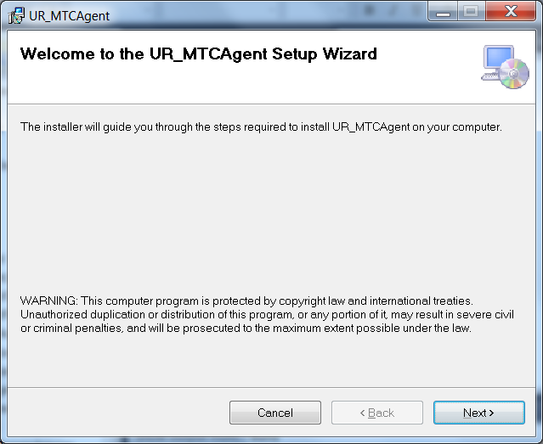

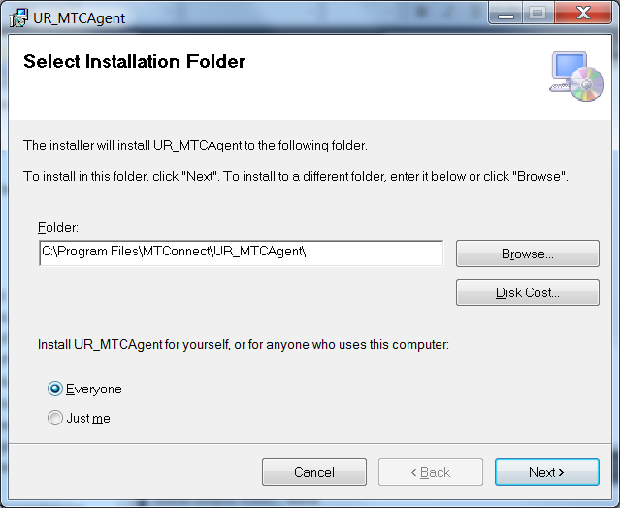

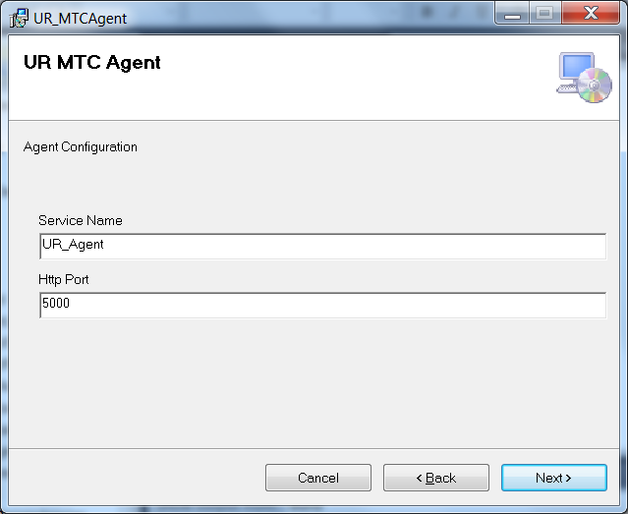

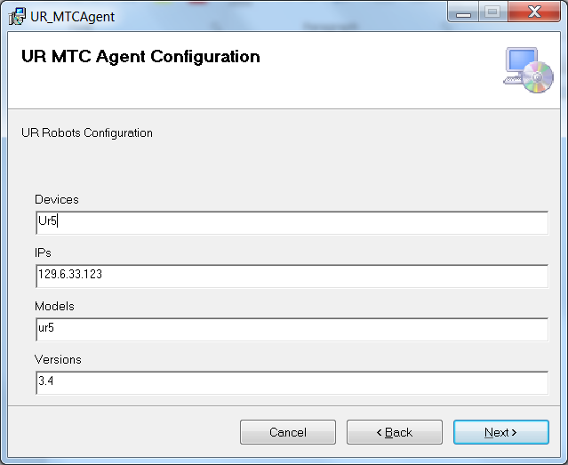

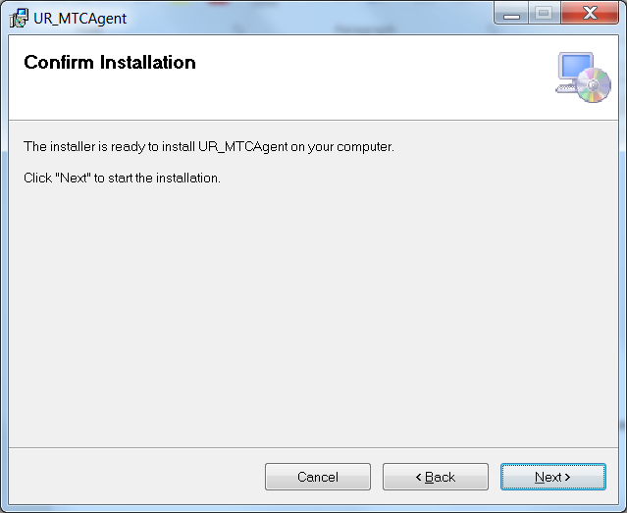

Acknowledge the installation permission challenge, then you should see the installation screen:

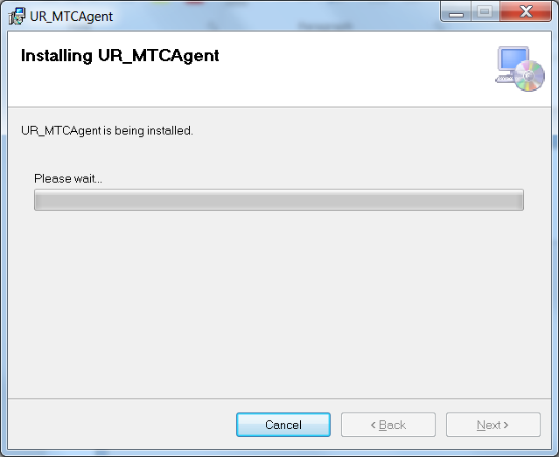

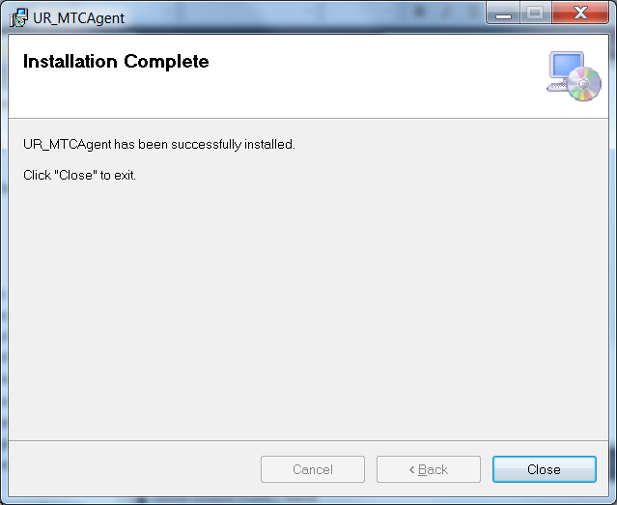

The Service installation is often precarious. So let's verify that the UR_Agent service was installed (although not started) in the Windows Service Control Manager (SCM)

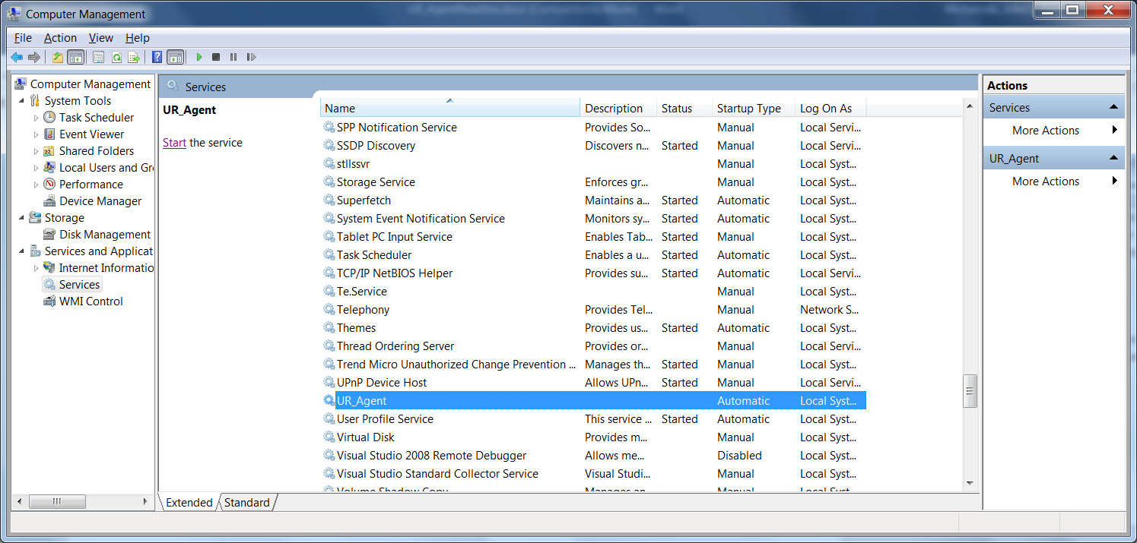

The agent will NOT start unless you tell it to START (unless you reboot).

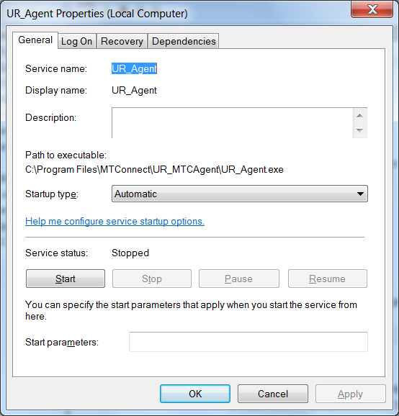

Manual installation of the UR MTC agent is of course possible. Change directory to the installation folder, and then right click on "Install.bat" and Run As Administrator. This assumes you have enough UAC privileges to do installation. If not you will need someone who will. If you are successful you should see the following DOS console screen flash before you eyes. (I added a pause to the end of the script to prevent the window from disappearing.)

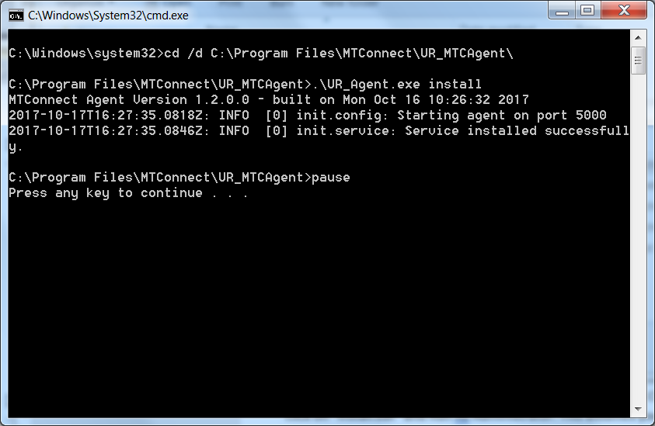

You should then see the UR_Agent service in the SCM. You can then start the service.

In the folder where the UR_Agent was installed (e.g., C:/Program Files/MTConnect/UR_MTConnectAgent), there is a vb script MTConnectPage-1.4.vbs, which can be used to verify that the log file Agent is working. MTConnectPage-1.4.vbs reads the data from the agent via <http://127.0.0.1:5000> and then formats the data. (assuming you have configured the agent port to 5000).

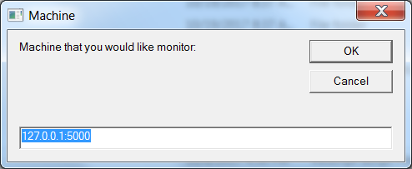

And once you enter the correct IP (local host) and the port number you specified for the MTConnect Agent (5000 in this case) you should see an Internet Explorer window popup containing the device(s) specified in your configuration. Shown below is the popup window for the device "Woodsy" and the data items specified for this device.

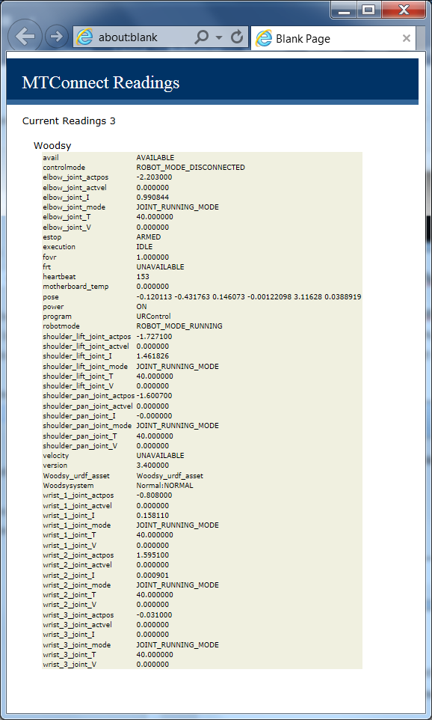

# Uninstall

First make sure the UR_Agent is stopped in the Service Control Manager:

Right click on My Computer -> Select Manage -> Acknowledge UAC challenge

Select Services and Applications and then Services, scroll down to UR_Agent, and push Stop button.

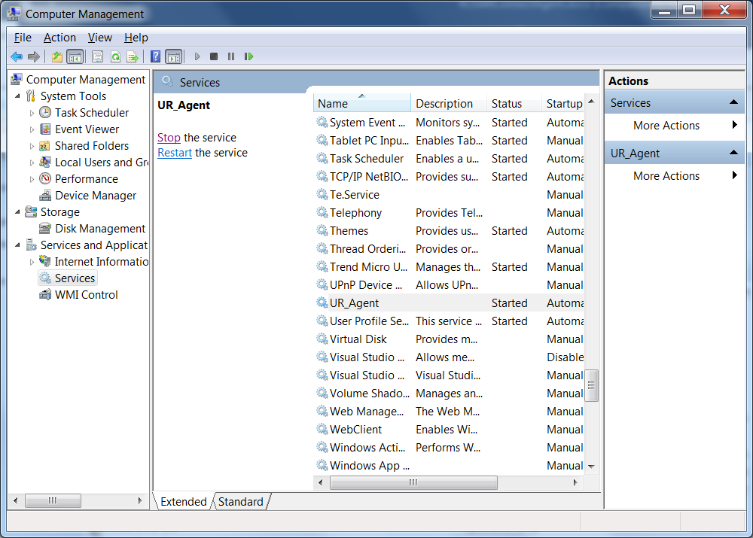

After you have stopped the UR_Agent service, go into the control panel and uninstall the program: UR_Agent

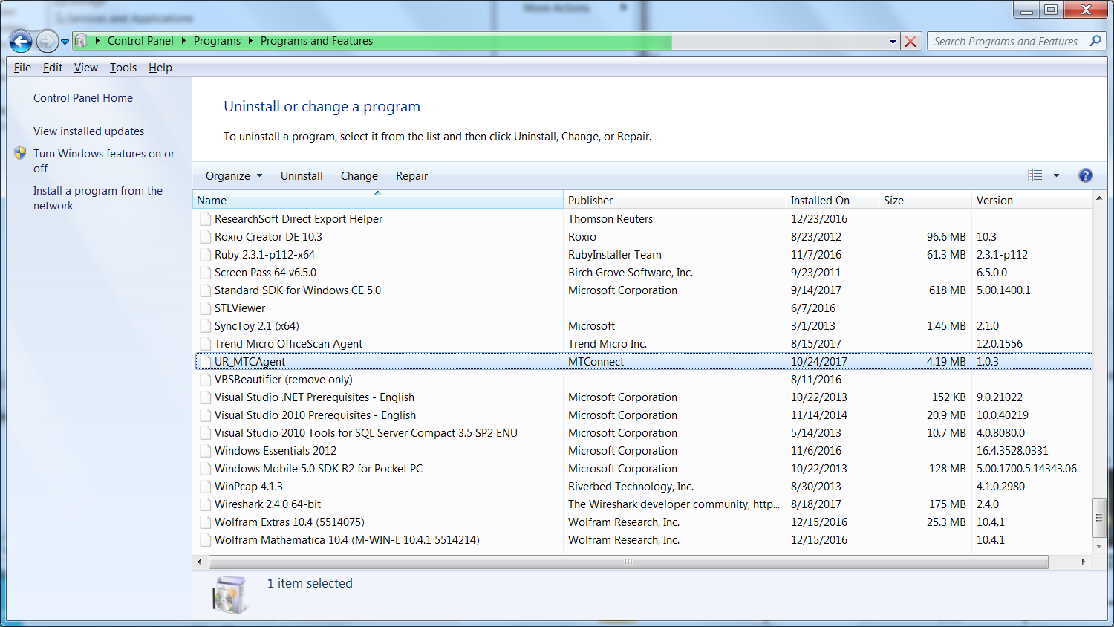

Click Uninstall UR_Agent

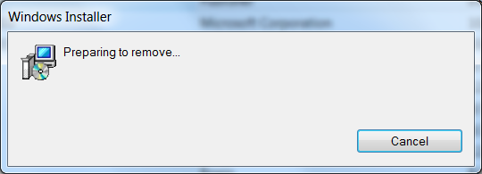

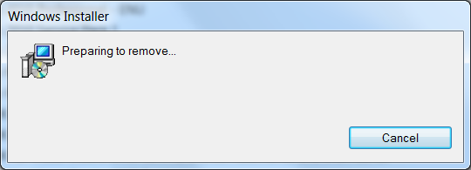

Please wait .. acknowledge UAC permission to uninstall challenge (you must be administrator or have administrator priviledges). It will uninstall and you may see a black console screen popup in the background momentarily.

And then in the Service Manager click Action->Refresh, and the UR_Agent service should be removed. The agent code in C:/Program Files/MTConnect/UR_MTConnectAgent should also be removed.

# Configuration

The UR MTConnect Agent uses the open-source MTConnect agent version 1.2 as the backbone to read http requests, generate XML responses, and update the underlying device data. There is a back-end communication and interpretation adapter addition to handle UR status information. The adapter can handle multiple device log file and update the core MTConnect agent. Typically, the configuration is done at installation time during the wizard screens. The user must supply pairs of device names, model of UR robots, URDF name file, and the version the UR robot communication interface supports.

However, the user can modify the config.ini file in the C:/Program Files/MTConnect/UR_MTConnectAgent folder. However, the devices.xml and the agent.cfg files necessary for the core MTConnect agent are generated at installation time, and thus a reinstallation would be required to modify these files.

In the config.ini file, you can manually change GLOBAL variables ServiceName, Agent http port, ResetAtMidnight flag, and list of MTConnect devices (which is specified as a comma separated list (CSV)). These changes will take if you stop/restart the Agent service or reboot the machine.

{GLOBALS]

Config=UPDATED

Version=3.2

ResetAtMidnight=false

Debug=0

MTConnectDevice=UR5

ServiceName=UR_Agent

logging_level=FATAL

QueryServer=10000

ServerRate=5000

HttpPort=5001

Thus, the agent reads the config.ini file for list of “MTConnectDevice”s under the Globals section. The configuration file also sets the Global flags: QueryServer, ServerRate, Debug, AgentPort(default 5000), and ResetAtMidnite.

For each MTConnectDevice in the list, a section must be created under which the variables, IP, jointnames, Version, Model and Urdf are assigned. The IP variable tells the agent the IP of the UR PC. The jointnames gives the names of the joints one which to use. The model tells the agent the robot type, and at this time is not used. And finally, the variable Urdf, tells the agent the name of the urdf file to use as an MTConnect asset.

[UR5]

IP=129.6.33.123

jointnames=shoulder_pan_joint,shoulder_lift_joint,elbow_joint,wrist_1_joint,wrist_2_joint,wrist_3_joint

Version=3.4

Model=UR5

Urdf=Ur5.urdf

## Manually Configuring UR Agent Directions

The installation wizard installs the log file Agent into the folder: C:/Program Files/MTConnect/UR_MTConnectAgent which is a 64-bit installation platform, e.g., windows 7. The MTConnect Agent executable must be paired with the correct platform (32 or 64 bit).

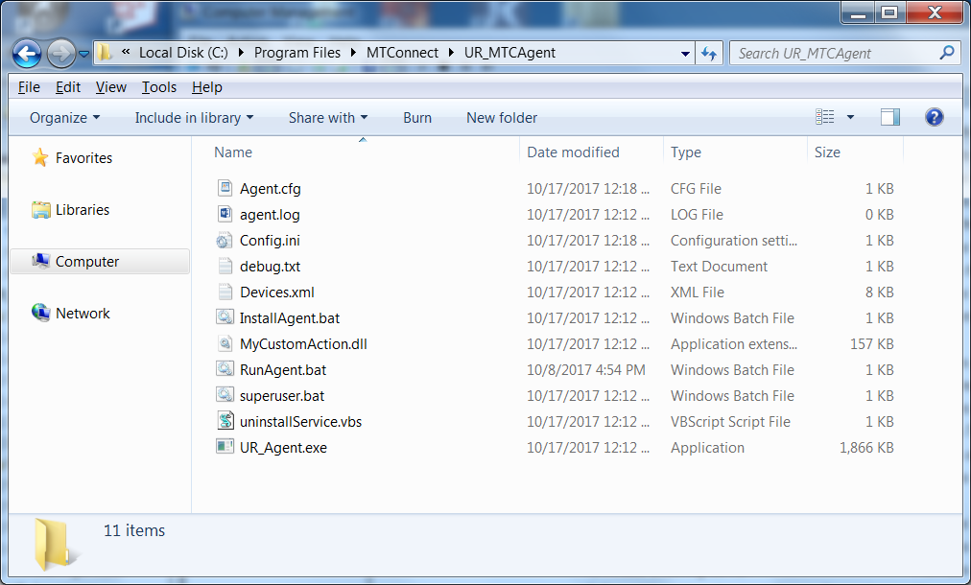

Modify Config.ini in C:/Program Files/MTConnect/UR_MTConnectAgent

1. Stop MTConnect agent, edit config.ini file, add new configuration:

[GLOBALS]

Config=NEW

This will cause a new devices.xml file to be generated.

1. Add new devices under [GLOBALS] section tag “MTConnectDevice” (spaces are stripped out) using a comma separated list (e.g., a,b,c) WHICH IS CASE SENSITIVE:

MTConnectDevice=UR5,UR3

1. Make sure there is an ini file “section” for each device (in this case UR5, UR3) and that the section has the three tags IP, jointnames and urdf. IP gives the TCP/IP address of the PC that hosts the UR controller and the jointnames give the list of joints for the given robot, while urdf defines the file to transfer as an asset through the MTConnect agent:

[UR5]

IP=129.6.33.123

jointnames= joint_1,joint_2,joint_3,joint_4,joint_5,joint_6

urdf=ur5.urdf

Version=3.4

[UR3]

IP=129.6.33.123

jointnames=shoulder_pan_joint,shoulder_lift_joint,elbow_joint,wrist_1_joint,wrist_2_joint,wrist_3_joint

Version=2.4

urdf=ur3.urdf

1. Start UR agent, the agent will detect a new configuration, and then write a new Devices.xml file to add the new devices.
2. If it works config.ini tag should say:

”Config=UPDATED” if a problem tag will say: “Config=ERROR”

## Use of NIST Information

This document is provided as a public service by the National Institute of Standards and Technology (NIST). With the exception of material marked as copyrighted, information presented on these pages is considered public information and may be distributed or copied. Use of appropriate byline/photo/image credits is requested.

## Software Disclaimer

NIST-developed software is provided by NIST as a public service. You may use, copy and distribute copies of the software in any medium, provided that you keep intact this entire notice. You may improve, modify and create derivative works of the software or any portion of the software, and you may copy and distribute such modifications or works. Modified works should carry a notice stating that you changed the software and should note the date and nature of any such change. Please explicitly acknowledge the National Institute of Standards and Technology as the source of the software.

NIST-developed software is expressly provided “AS IS.” NIST MAKES NO WARRANTY OF ANY KIND, EXPRESS, IMPLIED, IN FACT OR ARISING BY OPERATION OF LAW, INCLUDING, WITHOUT LIMITATION, THE IMPLIED WARRANTY OF MERCHANTABILITY, FITNESS FOR A PARTICULAR PURPOSE, NON-INFRINGEMENT AND DATA ACCURACY. NIST NEITHER REPRESENTS NOR WARRANTS THAT THE OPERATION OF THE SOFTWARE WILL BE UNINTERRUPTED OR ERROR-FREE, OR THAT ANY DEFECTS WILL BE CORRECTED. NIST DOES NOT WARRANT OR MAKE ANY REPRESENTATIONS REGARDING THE USE OF THE SOFTWARE OR THE RESULTS THEREOF, INCLUDING BUT NOT LIMITED TO THE CORRECTNESS, ACCURACY, RELIABILITY, OR USEFULNESS OF THE SOFTWARE.

You are solely responsible for determining the appropriateness of using and distributing the software and you assume all risks associated with its use, including but not limited to the risks and costs of program errors, compliance with applicable laws, damage to or loss of data, programs or equipment, and the unavailability or interruption of operation. This software is not intended to be used in any situation where a failure could cause risk of injury or damage to property. The software developed by NIST employees is not subject to copyright protection within the United States.

# Bibliography

|  |  |
| --- | --- |
| [1] | A. Larson, "Rethink's Baxter vs Universal Robots: Which Collaborative Robot is best for you?," 22 1 2013. [Online]. Available: cross-automation.com/blog/rethinks-baxter-vs-universal-robots-which-collaborative-robot-best-you. [Accessed 17 10 2017]. |
| [2] | T. Trautner, F. Pauker and B. Kittl, "ADVANCED MTCONNECT ASSET MANAGEMENT (AMAM)," in *International Conference on Innovative Technologies, IN‐TECH 2016*, Prague, 2016. |

# Source Code Documentation

This appendix describes some of the in-house developed source code used in deploying the UR MTConnect agent.

## Struct Decoder

The struct decoder performs conversions between network byte arrays and C++ structs. This intended for use in handling binary data from network connections. First, all the structure variables are declared. Then, preprocessor macros are used to define the size and order of the byte stream associated with this C++ struct. It assumes the struct is packed with no padding between variable elements. g each entry so they can easily be read/write/print including byte swapping if required. Implicit in this encoding process is the determination of the byte order of the host machine versus the prevailing network byte order (Big Endian), to determine whether byte swapping is necessary. If the byte order is not the same as network byte order, bytes are swapped to accommodate network byte order.

The struct_decoder struct is useful for reading/writing network byte streams. It uses the preprocessor definition to define a property table describing. The struct_decoder relies a printf specifier to format the variable for output, which conforms to the following table:

| **Format** | **C Type** | **Standard size**  **bytes** | **Notes** |
| --- | --- | --- | --- |
| %c | **Signed char** | 1 |  |
| %c | **unsigned char** | 1 |  |
| %uc | **unsigned char** | 1 |  |
| %c | **bool** | 1 |  |
| %u | **short** | 2 |  |
| %hu | **unsigned short** | 2 |  |
| %d | **int** | 4 |  |
| %ud | **unsigned int** | 4 |  |
| %ld | **long** | 4 |  |
| %uld | **unsigned long** | 4 |  |
| %lld | **long long** | 8 |  |
| %ulld | **unsigned long long** | 8 |  |
| %f | **float** | 4 |  |
| %lf | **double** | 8 |  |
| %Lf | **long double** | 16 |  |
| %s | **char[]** |  |  |

Array serial properties use these printf to format each element in the array.

The "Curiously Recurring Template" pattern is used to assist in decoding by allowing access to the outermost serial property map. Thus, each structure that uses the serialization decoding mechanism, inherits from "struct_decoder" template class, but provides itself as the template type. This is useful if the structure inherits from a structure that itself has a serial property map.

struct ur_cartesian_info : public struct_decoder<ur_cartesian_info>

The "Curiously Recurring Template" is useful when you need to access the outer class variables or methods. This is used to get the outer serial property map defined in the class, as shown in the struct_decoder base class:

template <class T>   
struct struct_decoder

{

. . .

PropertyMap *props = static_cast<T *>(this)->GetPropertyMap();

There are a collection of C++ macros that handle the building of the property map that are used by the "Curiously Recurring Template" struct_decoder. These include:

* BEGIN_SERIAL_PROP_MAP (X) marks the beginning of the classes' serial property map. It creates a msgname class to return ASCII string containing the message name (denoted by the preprocessor X). It also declares a the beginning of a static method GetPropertyMap(), which gives a reference pointer to the embedded static table of serialization variables.
* PROP_SERIAL_ENTRY (mName, pformat) defines a preprocessor macro that inserts an entry into the serial property map table. It expects an existing class member variable name, and uses the mName to save the name, sizeof, and offset of the variable from beginning of the class definition (including any inherited classes definitions). Pformat defines a printf like formatting string for use in the print struct_decoder method.
* PROP_SERIAL_ENTRY_VERSION(mName, pformat,min,max) defines a preprocessor macro that inserts an entry into the serial property map table, much like PROP_SERIAL_ENTRY. However, this time it also enter a min and max version number in floating point (e.g., 3.4) into the serial property table. VMAX and VMIN are macros to indicate the limits of the versioning in either direction.
* PROP_SERIAL_ENTRY_VARARRAY(mName, mSize, pformat, var) defines a preprocessor macro that inserts an array entry into the serial property map table. mName and pformat are used as int PROP_SERIAL_ENTRY. mSize defines the size of each element in the array, will the var entry defining a pointer to the variable defining the actual size of the array. For example, below DHa is the name of the variable, and element size is the sizeof(double), the format is "%lf" for a double, and the pointer to the defining array size is given by &numjoints.

PROP_SERIAL_ENTRY_VARARRAY(DHa, sizeof( double ), "%lf", &numjoints)

Note, the max size of the array is given by the sizeof(DHa) so it must be allocated as a declared array size, not as a std::vector. Using this information, we can insure that the size given by numjoints does not exceed the maximum declared array size.

double DHa[8];

* END_SERIAL_PROP_MAP() marks the end of the serial property map.
* PROP_SERIAL_ENTRY_BASE(mName) allows the current structure to reference an inherited structure with a serial property map of its variables. It is no used in the UR Agent implementation.

For example, the class ur_cartesian_info illustrates the use of the inheritance, range of applicability using minimum and maximum verion numbers, use of pragma to insure variables are packed,

struct ur_cartesian_info : public struct_decoder<ur_cartesian_info>

{

float mVersion;

#pragma pack(push, 1)

double X;

double Y;

double Z;

double Rx;

double Ry;

double Rz;

double TCPOffsetX;

double TCPOffsetY;

double TCPOffsetZ;

double TCPOffsetRx;

double TCPOffsetRy;

double TCPOffsetRz;

#pragma pack(pop)

BEGIN_SERIAL_PROP_MAP(ur_cartesian_info)

PROP_SERIAL_ENTRY(X, "%lf")

PROP_SERIAL_ENTRY(Y, "%lf")

PROP_SERIAL_ENTRY(Z, "%lf")

PROP_SERIAL_ENTRY(Rx, "%lf")

PROP_SERIAL_ENTRY(Ry, "%lf")

PROP_SERIAL_ENTRY(Rz, "%lf")

PROP_SERIAL_ENTRY_VERSION(TCPOffsetX, "%lf",3.1,VMAX)

PROP_SERIAL_ENTRY_VERSION(TCPOffsetY, "%lf",3.1,VMAX)

PROP_SERIAL_ENTRY_VERSION(TCPOffsetZ, "%lf",3.1,VMAX)

PROP_SERIAL_ENTRY_VERSION(TCPOffsetRx, "%lf",3.1,VMAX)

PROP_SERIAL_ENTRY_VERSION(TCPOffsetRy, "%lf",3.1,VMAX)

PROP_SERIAL_ENTRY_VERSION(TCPOffsetRz, "%lf",3.1,VMAX)

END_SERIAL_PROP_MAP( )

} ;

The defines the structure and uses the

struct ur_cartesian_info : public struct_decoder<ur_cartesian_info>

{

The mVersion variable must be inserted into every outer class so that multiple instances of the ur_cartesian_info struct can support multiple versions of the interface. It is manually inserted so that programmers are aware that versioning is being done, and the version must be specified. Thus a 3.0 UR robot and a 3.4 UR robot can each use the ur_cartesian_info definition, and by putting in either 3.0 or 3.4 different interfaces are supported during decoding.

float mVersion;

In the definition of ur_cartesian_info, the Microsoft C++ compiler pragma pack is used to ensure that the variables are slotted with their native size and no padding is performed. Thus, before the start of the variables to be decodes from a binary representation, the pragma is used:

#pragma pack(push, 1)

double X;

. . .

#pragma pack(pop)

The serial property map for each structure must be defined to allow the decoding (read) and the encoding (write) of raw binary message. Implicit in this transcribing process is the determination of the byte order of the host machine, to determine whether it is the same as network byte order or not. If the byte order is not the same as network byte order, bytes are swapped to accommodate network byte order.

BEGIN_SERIAL_PROP_MAP(ur_cartesian_info)

PROP_SERIAL_ENTRY(X, "%lf")

. . .

END_SERIAL_PROP_MAP( )

Changes due to versioning in the ur_cartesian_info struct occur in version 3.1 So, in the property serial map specification, the version ranges from VMIN to 3.1 to VMAX. So, the version 3.0 would not support the TCPOffsetX variable, while the version 3.1 would. Below the X variable is declared in the preprocessor macro PROP_SERIAL_ENTRY where the version implicitly ranges from VMIN to VMAX:

PROP_SERIAL_ENTRY(X, "%lf")

Below the TCPOffsetX variable is declared in the preprocessor macro PROP_SERIAL_ENTRY_VERSION to be viable from version 3.1 on:

PROP_SERIAL_ENTRY_VERSION(TCPOffsetX, "%lf",3.1,VMAX)

Once the structure has been setup to be decoded (and encoded), raw messages from the UR robot can be unpacked into the structure. Assuming a socket reader has been coded, we assume a variable "buf" contains a raw binary message, with a given offset (generally including or not including header) and the variable len describing the length of the message. The ur_robot_state::unpackRobotState accepts these parameters on the stack to decode the UR message, in the following code:

void ur_robot_state::unpackRobotState (uint8_t *buf, unsigned int offset,

uint32_t len)

{

// package_types

offset += 5;

while ( offset < len )

{

ur_message_header hdr;

hdr.read((char *) &buf[offset]);

switch ( hdr.packageType )

{

case package_types::CARTESIAN_INFO:

{

_ur_cartesian_info.read((char *) &buf[offset + hdr.msglength( )]);

}

break;  
. . .

}

offset += hdr.packageSize;

}

The header offset describing the outer message type and length (of length 5 bytes) is added to the offset within the message.

// package_types

offset += 5;

Then the header message describing the type and length of the message is decoded using the ur_message_header decoding "read" routine:

ur_message_header hdr;

hdr.read((char *) &buf[offset]);

Using the hdr packageType can be used in a C++ switch statement to determine the type of the inner message:.

switch ( hdr.packageType )

{

We will assume that a ur_cartesian_info message is to be decoded. Then the package_types::CARTESIAN_INFO case will be matched:

case package_types::CARTESIAN_INFO:

{

_ur_cartesian_info.read((char *) &buf[offset + hdr.msglength( )]);

}

break;

And then the ur_cartesian_info.read routine will read (i.e.,decode) the buffer starting at position buf+offset with message length equal to hdr.msglength( ) that is determined dynamically each time in consideration of a potential version and resulting message length change.

# Logging

There is limited logging capability within the UR Agent. The logging facility is based on ROS Console open source code, which can be found at <https://github.com/ros/console_bridge/blob/master/include/console_bridge/console.h>. ROS provides interesting C++ Logging filtering macros (once, periodically, etc.) here: <https://github.com/ros/ros_comm/blob/4383f8fad9550836137077ed1a7120e5d3e745de/tools/rosconsole/include/ros/console.h> Although the logging facility is very robust and can be extracted out of the ROS framework with a little effort, the code base was too extensive to justify the work.

The logging is global in scope in that the all diagnostic log messages are output to the class GLogger. GLogger is defined as an instance of class CLogger. Within the instance, there are several flags which can be used to change the logging functionality. One flag is accessed by the method DebugConsole() , with 0 giving no "OuputDebugConsole" for windows, and 1 echoing the logging message to output. There is a level determined by the method DebugLevel() which determines the threshold of diagnostic activity, which is explained a bit later. The flag Timestamping( ) determines whether a timestamp will be prepended to every diagnostic message. If Timestamping( ) is true, timestamps will be appended. For example, the logStatus message with a timestamp is shown below:

2017-10-24 09:23:57.0259 Start UR_ Agent

The CLogger variable DebugFile() determines the filename in which log messages are appended. By default the filename is debug.txt and the location of the file is in the execution application directory.

Users of applications can indeed create different log file using CLogger and DebugFile(), however, one will be limited to the logging method: logmessage (const char *file, int line, LogLevel level, const char *fmt, ...) to log message. Plus, the macros described below only output to GLogger, which take advantage of the logmessage method.

The logging level [-1..5] determines the amount of logging that will be done. Each numeric value corresponds to a threshold where logging will be done. 0 corresponds to Fatal, 1 corresponds to Error, 2 corresponds to Warning, 3 corresponds to Inform, and 4 corresponds to Debug.

System logging threshold omit logging with a diagnostic level above the system level. For example a system logging level of 3 will omit debug message (logging level 5)

* logAbort(fmt, ...) Something unrecoverable has happened. Application will terminate imeediately, and not gracefully.
* logFatal(fmt, ...) Something catastrophic has happened, attempt to shut the application down.
* logStatus(fmt, ...) Information that is provided regardless of logging level.
* logError(fmt, ...) Something serious (but recoverable) has gone wrong.
* logWarn(fmt, ...) Information that the user may find alarming, and may affect the output of the application, but is part of the expected working of the system.
* logInform(fmt, ...) Small amounts of information that may be useful to a user.
* logDebug(fmt, ...) Information that you never need to see if the system is working properly.

There is logging level of None but it is unclear if this is obeyed.

Below is an example of the use of the logDebug macro. It accepts a character string as format, and a variable length of arguments follow determined by the format statement. It uses stdargs to handle the variable arguments.

#include "NIST/Logger.h"

. . .

logDebug("\tAdapter %s Server Rate=%d\n", mDevice.c_str(), mServerRate);

. . .

There is a C++ macro LOG_ONCE(X) to limit the logging output to only once. For example, the previous code can be output once by the following code modification:

#include "NIST/Logger.h"

. . .

LOG_ONCE (

logDebug("\tAdapter %s Server Rate=%d\n", mDevice.c_str(), mServerRate);

)

. . .

There is also a LOG_THROTTLE(secs, X) based on the ROS filtering methodology, that will limit the output of a log to be periodic based on the rate as determined in seconds. Thus, in the example below, the diagnostic message will be output throttled down to once every minute.

#include "NIST/Logger.h"

. . .

LOG_ THROTTLE (60,

logDebug("\tAdapter %s Server Rate=%d\n", mDevice.c_str(), mServerRate);

)

. . .